We need to make a broadband LED system so we choose. Lumileds L1IG-0750100000000 SMD LED. Detail information can be found in the following link <https://www.mouser.com/ProductDetail/Lumileds/L1IG-0750100000000?qs=UXgszm6BlbFsaqyaTO4YIQ%3D%3D&countryCode=KR&currencyCode=KRW>

The size of the LEDs is 2.75 mm \* 2.00 mm. We want to assemble them in 50 mm diameter area.

I have attached here schematic of the LED assemble. All dimensions in the drawing are in mm.

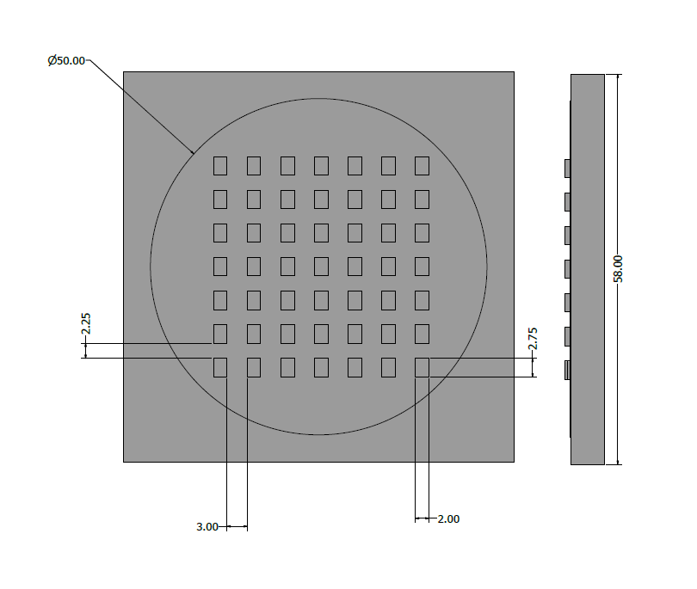

The objective of this LED arrangement is to make a LED system that can be used for hyperspectral imaging. Our target illumination area is human face. The standard size of the human face is 21 cm \*21 cm.